REDUCING THE FOOTPRINT OF FOOD

**ABSTRACT**

we describe the design and development of SQUID (Street Quality Identification Device), a low-cost sensor platform mounted on official city vehicles to passively measure street surface quality by combining a microcomputer, accelerometer, GPS and a camera to build an image database of the underlying street surface quality across the entire city. The collection of this data, at scale, would thus represent a low-cost baseline to make strategic and operational decisions about street resurfacing.

# Categories and Subject Descriptors

Python, Linux, Sensor networks

# General Terms

Algorithms, Management, Measurement, Design, Experimentation, Verification.

# Keywords

Raspberry Pi, accelerometer, GPS, image processing, potholes, street defects, big data, common operational picture, situational awareness, decision making, internet of things, NYC Dept. of Operations, Street Conditions Observation Unit, SCOUT

# BACKGROUND

Few initiatives exist that involve the development of a low cost device to passively collect data about city street quality in a continuous, reusable manner. Previous attempts have been largely experimental involving a single specialized vehicle fitted with large, expensive, military grade sensor equipment that over- engineers the problem without achieving scalable means to collect data necessary to make street resurfacing decisions. Moreover, these attempts have approached the problem as a techno-centric rather than systems centric. Our approach allows for a systematic approach recognizing the people and institutions involved

in street maintenance operations. We recognize that the problem is complex and includes a large public facing component and is deeply embedded in several political bureaucracies. These issues are not in scope for this paper but our design philosophy recognizes this complex environment.

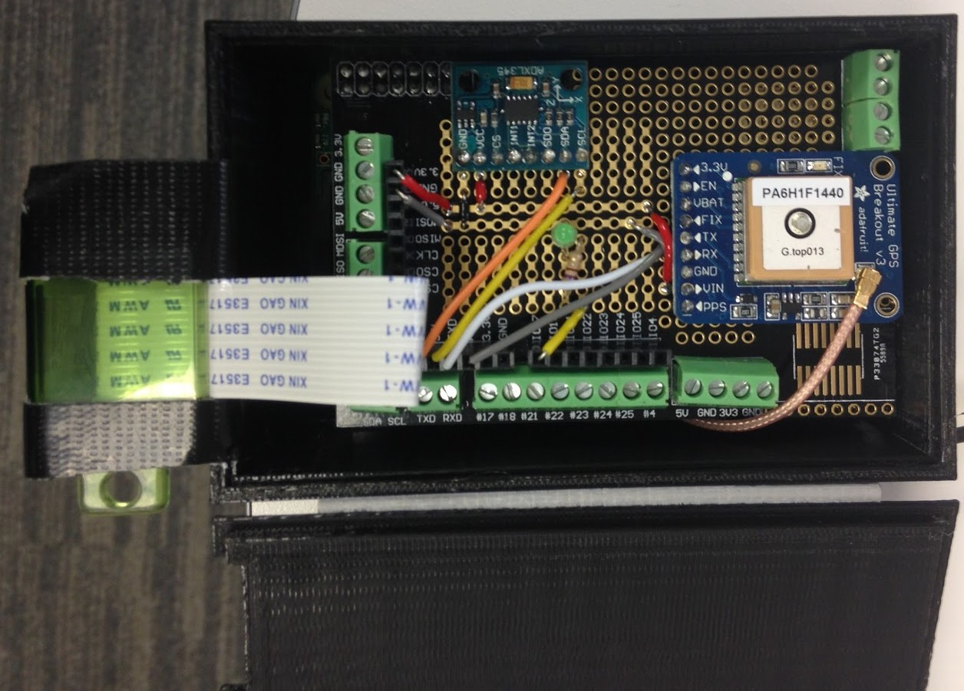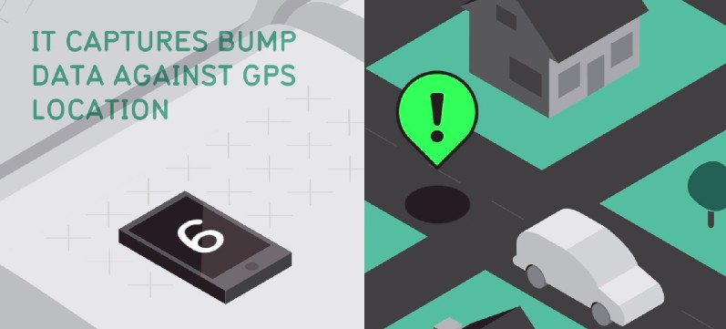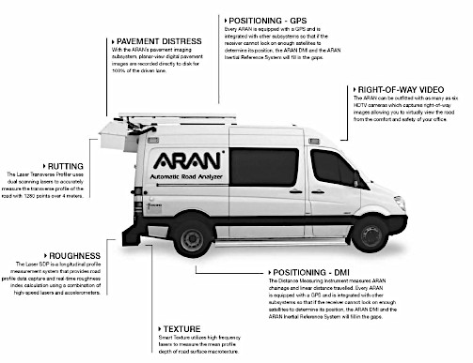

SQUID

**ABSTRACT**

The explosive development of the concept of Internet of Things (IoT) is accompanied by an unprecedented revolution in the physical and cyber world. Smart, always- connected devices provide real-time contextual information with low overhead to optimize processes and improve how companies and individuals interact, work, and live. An increased number of businesses, homes and public areas are now starting to use these devices.

